Jade Pearl
COSC 320-001 Lab 07: Hash Tables 3/28/2023

Lab report: I completed this lab in approximately hours.

Pre-lab:
- Review the in-class material we have discussed about hash table and hash function
- Read and understand the header files d_hash.h, d_hashf.h, d_hiter.h

Files Created:
Lab_07.cpp

Lab 7
Exercise 1: Read dict.dat file and insert words into a hash table with 1373 buckets. The file dict.dat contains 25025 frequently used words, each on a separate line in lowercase
Exercise 1.a: Prompt for the name of a document, read the document, and separate it into a sequence of words converted to lowercase by calling the function getWord
Exercise 1.b: use the hash table to output a list of words that appear to be misspelled
Exercise 2: use sample input file spelltst.txt or your own input file for spell checking. Compare the output with the sample output using the given spelltst.txt input file

Source Code:
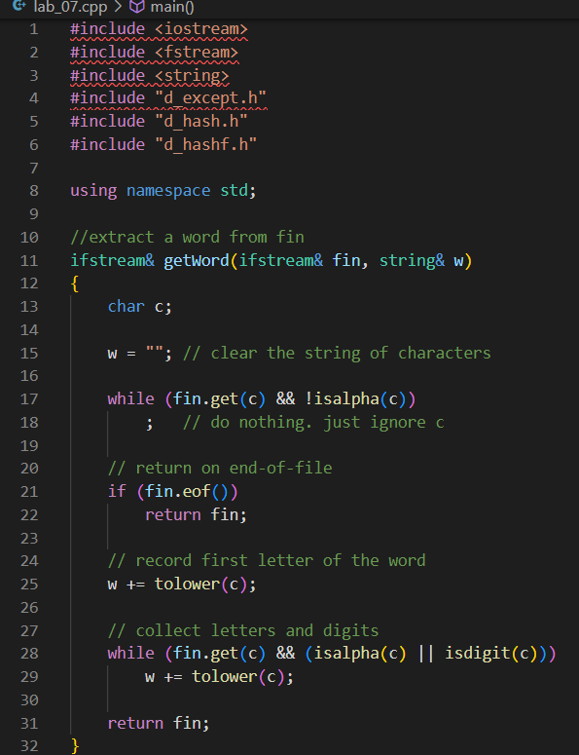
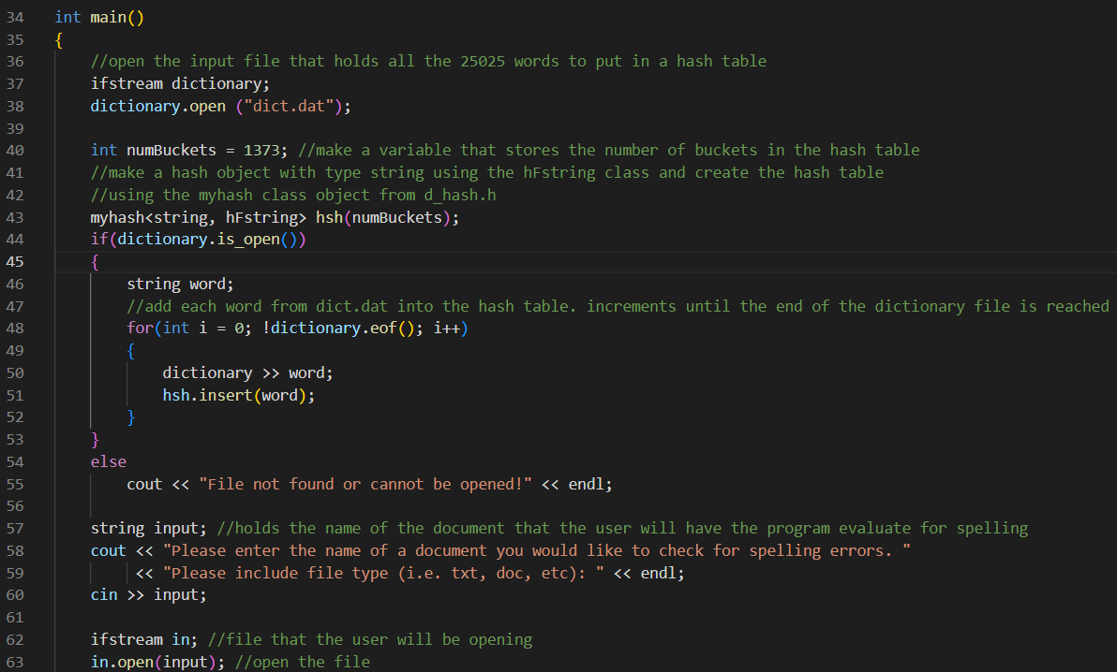
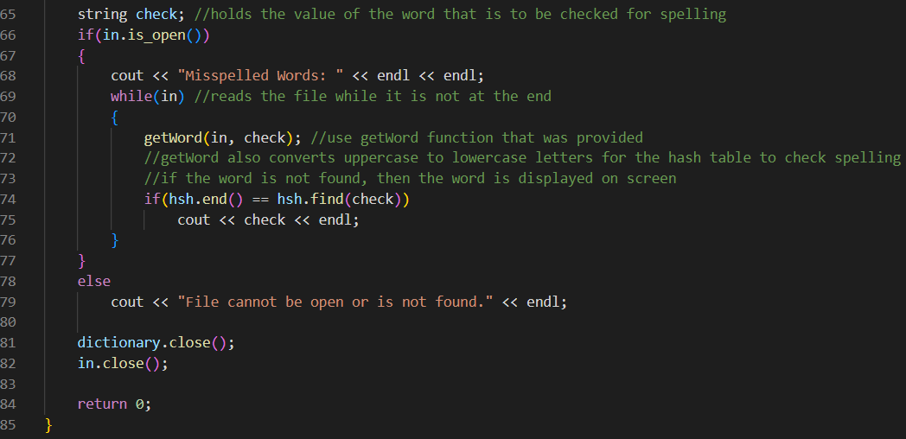

Sample Outputs:
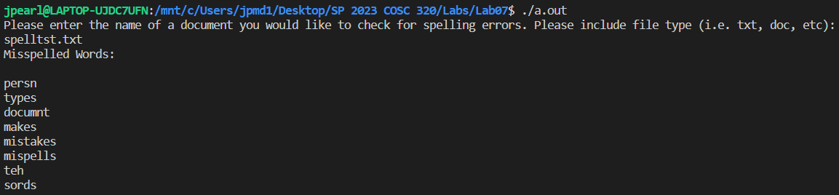
This matches the sample output given in the lab instructions!

